William Frank
1/31/20
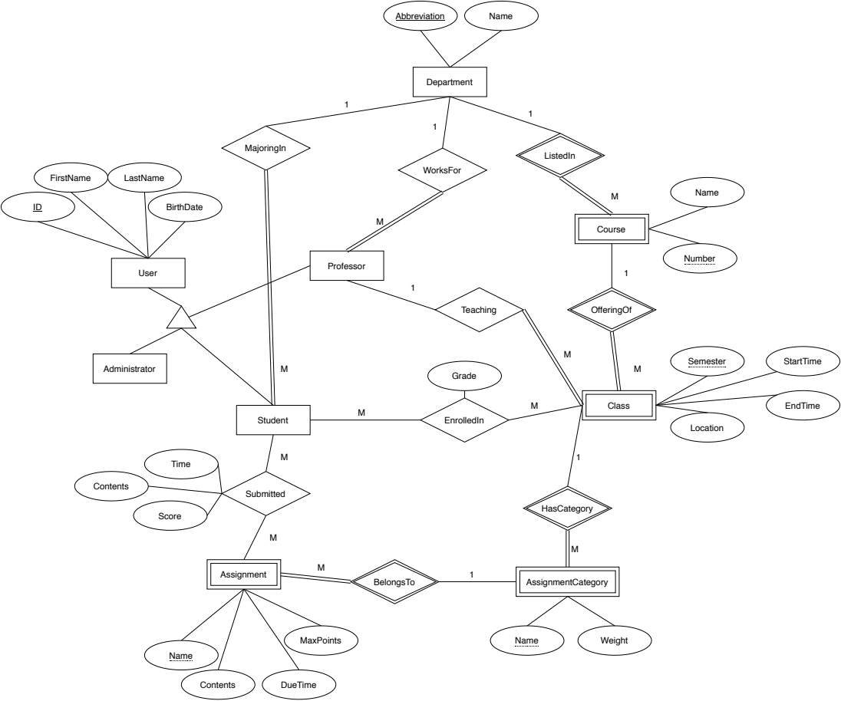
Database Systems – Project Phase 1

